
Infection Prevention and Control (IPC)

Self-assessment Checklist for Educational Settings
Name of Setting |  | Address (including postcode):
Assessor’s name: |  | Assessor’s role:
Date completed: |  | Review Date:

Contents
Document Control 3
Introduction 4
Importance of IPC 4
Purpose of this self-assessment checklist 4
1. Vaccinations 5
2 Minimise contact with individuals who are unwell 6
3. Hand Hygiene 8
4 Respiratory Hygiene 10
5 Cleaning 11
6 Laundry 13
7 Ventilation 14
8 Personal Protective Equipment (PPE) 15
9. UKHSA Posters 16

Document Control
Organisation | Devon County Council/ Plymouth City Council/ Torbay Council
Title | IPC Checklist for Educational Settings
Creator
Approvals
Distribution | Public
Owner
Protective Marking | Unclassified
Review due date

Document Amendment History
Revision No. | Originator of change | Date of Change | Change Description
1 | Health Protection – Torbay Council and Devon County Council | Summer 2024 | Addition of vaccination information. Changes to look and feel to include images and document control section.
2 | Health Protection, Torbay Council | January 2026 | Two typos corrected. Shadow removed from image on title page.

Introduction

Importance of IPC
The main way of spreading infections is through close contact with an infected person. For instance, when someone with flu like symptoms breathes, speaks, coughs or sneezes, they release particles (droplets and aerosols) containing the germs. These particles can be breathed in by another person. Surfaces and belongings can also be contaminated with microorganisms when people who are infected cough or sneeze near them or if they touch them. If someone has an infection, there is a risk that they will spread it onto surfaces such as furniture, benches or door handles even if you do not touch them directly. The next person to touch that surface may then become infected.

Purpose of this self-assessment checklist
This checklist is designed to support educational settings, with meeting the required standards to protect all its people from infectious diseases within that setting. All education settings are encouraged to complete at the beginning of term and repeat on a regular basis to help ensure that all measures remain in place.
The checklist can also be used to inform the educational settings overall site risk assessment. The checklist does not cover outings outside of the main premises but can be used to support these activities.
It supports compliance and adherence with the infection prevention and control measures that are required to meet those standards. It is aligned with, and builds upon, existing Health protection in children and young people settings, including education - GOV.UK (www.gov.uk) structured around protective IPC measures and gives assurance that all steps are taken to protect people from infections.
It should be used alongside the Health and safety: responsibilities and duties for schools guidance. All education settings are encouraged to implement the NICE recommendations for childcare and education providers.

Instructions: A nominated person should undertake this assessment, completing their contact details above. If any issues have been identified, then these should be escalated to the person in charge for action to ensure that all the requirements are met. You can also contact the Torbay Council Public Health, Health Protection Team for any IPC advice or request a site support visit.

1. Vaccinations |  | Yes | No | Comments/Actions required
1.1 | Many infections are preventable through vaccines. Achieving high levels of immunity against vaccine preventable diseases is vital to reduce the spread of infection and prevent outbreaks.
1.2 | Staff  It is important that all staff are up to date with relevant vaccinations.  Complete routine immunisation schedule - GOV.UK (www.gov.uk) or  https://www.gov.uk/government/publications/the-complete-routine-immunisation-schedule  This outlines the UK vaccination schedule. Staff can check the NHS app or speak to their GP or practice to check their immunisation records. If there are any missing, they just need to book in with their GP to be immunised. There is no prescription charge for these.  The MMR vaccine is the safest and most effective way to protect yourself against measles, mumps and rubella, which are viral infections that can quickly spread and cause outbreaks. If two doses have not been given.  Have you shared the routine immunisation schedule with staff (including volunteers)?
1.3 | Children  Vaccinations are delivered early in childhood by primary care and then later by the School Aged Immunisation Service.  Delivering immunisations in school can make access to vaccination and healthcare easier for all, and so can help to reduce health inequalities.  Education settings have a central role to play in supporting routine immunisations, including through sharing information with parents and caregivers and facilitating the Schools Aged Immunisation Teams to deliver vaccinations in school.  Do you routinely share information with parents and carers about childhood vaccinations?
2 Minimise contact with individuals who are unwell |  | Yes | No | Comments/Actions required
2.1 | All staff and children are advised to stay away from the setting environment when they feel unwell with symptoms of an infectious disease such as respiratory viruses and Diarrhoea & Vomiting (D&V) for the advised amount of time. More information can be found Managing specific infectious diseases: A to Z - GOV.UK (www.gov.uk) as well as NHS Conditions.  Is this part of your sickness/ absence policy for staff and children?

2.2 | Has this poster has been shared with all parents and carers?  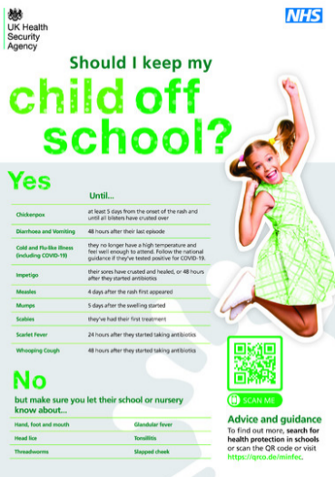
2.3 | Do staff know how and when to contact the UKHSA Health Protection Team (HPT) for help and advice?  After consulting the Managing specific infectious diseases: A to Z - GOV.UK (www.gov.uk) and suspect cases of infectious illness at your setting but are unsure if it is an outbreak, please call your local UKHSA health protection team Contact details here.  Managing outbreaks and incidents - GOV.UK (www.gov.uk)
2.4 | Is a separate room/area is available (with appropriate supervision) for anyone that may become unwell during the day who is unable to leave the setting immediately? |  |  | Detail room/area identified
2.5 | Does this area have hand washing facilities, surfaces that are clutter free and easy to clean, personal protective equipment (PPE) readily available, and a window which can be opened or is well ventilated?

3. Hand Hygiene |  | Yes | No | Comments/Actions required
Hand hygiene is the act of cleaning hands for the purpose of removing soil, dirt, and microorganisms and is a primary measure for reducing the risk of transmitting infection.

3.1 | Have all staff and pupils been educated in the correct way to clean their hands and when and why they need to clean their hands?
3.2 | Are hand Washing posters displayed by all sinks? Examples below from WHO hand washing poster and Torbay Council)  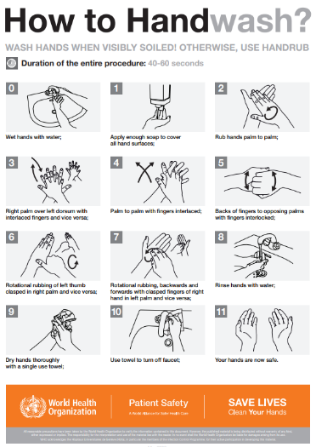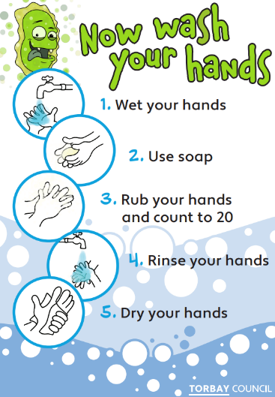
3.3 | Is hand sanitiser available where there is no sink available at risk assessed sites where hand hygiene should be completed?  e.g. entrances and exits points.  Are checks undertaken to ensure these are refilled as required?  NB: hand sanitiser is not effective for all viruses e.g. norovirus

3.4 | Are hand sanitiser posters displayed by all hand sanitiser dispensers?  (WHO Hand rub poster)  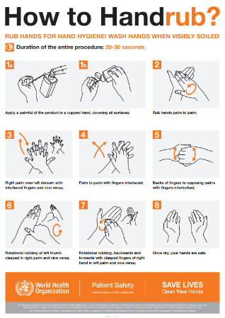
3.5 | Is liquid soap available at all hand washing sinks?  Ideally, warm water should be available as this encourages individuals to wash their hands for longer.
3.6 | Can hands be dried adequately?  Paper towels are preferred. Hand dryers should be in good working order.
3.7 | Are foot operated bins available for disposal of waste/paper towels/ tissues?
3.8 | Are bins in clean and good working order?  Replace any broken bins.

4 Respiratory Hygiene |  | Yes | No | Comments/Actions required
‘Coughs and sneezes spread diseases.’ Everyone should be encouraged to cover their mouth and nose with a disposable tissue and wash hands after using or disposing of tissues. Spitting should be discouraged.
4.1 | All staff and pupils are educated in respiratory hygiene as outlined above.  See: Home (e-bug.eu)
4.2 | Respiratory hygiene posters are on display in staff and pupil areas (e-Bug poster, Catch it, Bin it, Kill it poster).  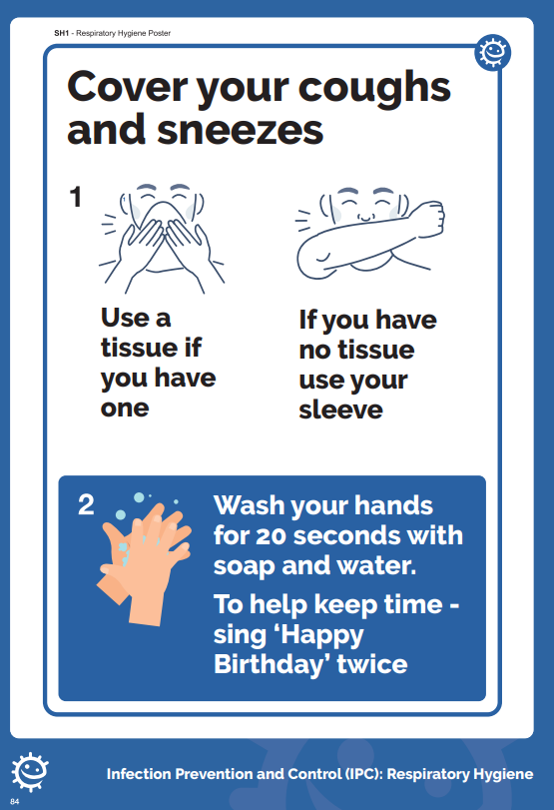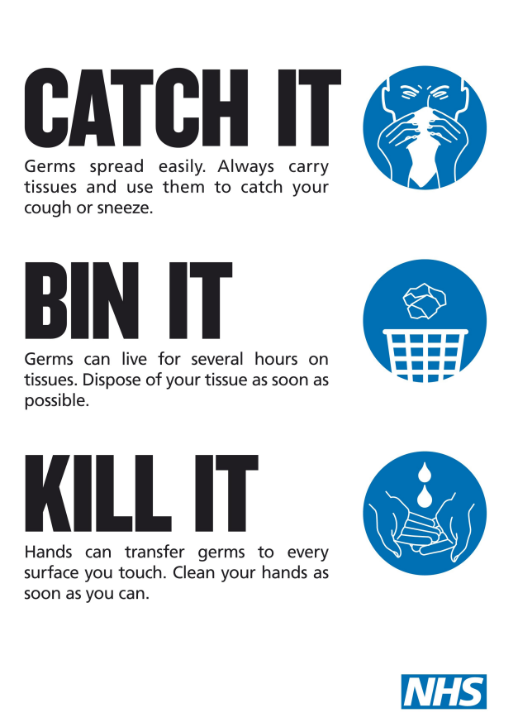
4.3 | Are disposable tissues available to promote good respiratory hygiene?
4.4 | Are waste bins available to encourage swift disposal of used tissues – followed by hand hygiene?

5 Cleaning |  | Yes | No | Comments/Actions required
Regular cleaning plays a vital role in limiting the transmission of harmful infections.
Cleaning of the environment, including toys and equipment, is an important function for the control of infection in childcare settings. It is important that cleaning schedules clearly describe the activities needed, the frequency and who will carry them out. Cleaning standards should be monitored regularly by the setting. Cleaning staff should be appropriately trained and have access to personal protective equipment. Reducing clutter and removing difficult to clean items can make cleaning easier.
5.1 | The environment has been decluttered and all non-essential items removed from all rooms, corridors and other shared spaces.
 | During an outbreak (5.2-5.4):
5.2 | The use of shared resources has been reduced wherever possible.
5.3 | Frequently touched surfaces should be wiped down at least twice a day, and one of these should be at the beginning or the end of the working day using your usual cleaning materials.
5.4 | There is an enhanced cleaning of shared areas that are used by different groups that includes cleaning frequently touched surfaces more often than normal at times of outbreaks, such as:  door handles,  handrails,  tabletops,  play equipment,  toys,  electronic devices (such as phones and computer keyboards)
5.5 | Cleaning schedules are kept and monitored to ensure standards are maintained. Cleaning schedules should include information about who cleans what, when and how.
5.6 | A colour coding system is in place for cleaning equipment.  Colour-coded cleaning equipment should be used in different areas with separate equipment for kitchen, toilet, classroom and office areas (for example, red for toilets and washrooms, blue for general areas, green for kitchens and yellow for cleaning areas where an infectious case has been).
5.7 | PPE is worn for cleaning in line with COSHH for the task being completed and the products being used.  Gloves and disposable apron may be needed when using certain cleaning products (check manufacturer data sheets). Face mask and eye protection should be worn if risk is high (i.e. cleaning areas where there are visible bodily fluids.)
5.8 | Disposable cloths and mop heads etc are available for cleaning after a confirmed/suspected infectious case attending the premises. They are disposed of after use.
5.9 | When a case of suspected or confirmed infection has been identified at the setting then one of the following cleaning and disinfection regimes is used:  a combined detergent disinfectant solution at a dilution of 1,000 parts per million available chlorine (ppm av.cl.)  or  a household detergent followed by disinfection (1000 ppm av.cl.). Follow manufacturer’s instructions for dilution, application and contact times for all detergents and disinfectants  or  if an alternative disinfectant is used within the organisation ensure that it is effective against the suspected/confirmed organism causing the infection  Steam cleaning should be used when items that cannot be cleaned using detergents or laundered, for example, upholstered furniture and carpets.  Guidance: Cleaning effectively in your business | Food Standards Agency |  |  | Document here the product used
5.10 | Any spillages of blood, faeces, saliva, vomit, nasal and eye discharges should be cleaned immediately, wearing PPE. Use gloves and an apron if anticipate splashing and risk assess the need for eye protection. Following manufacturer’s guidance, Spillages must be cleaned using a product which combines detergent and disinfectant that is effective against both bacteria and viruses.  Use disposable paper towels or cloths to clean up blood and body fluid spills. These should be disposed of immediately and safely after use. A spillage kit can be useful for bodily fluids like blood, vomit and urine.
5.11 | All staff including volunteers have received internal training on organisation’s cleaning procedures for spillages noted above.
6 Laundry |  | Yes | No | Comments/Actions required
6.1 | Items are washed in accordance with manufacturer’s instructions. Use the warmest water setting recommended by the manufacturer and dry items completely.
6.2 | Washing machines and tumble dryers are in good working order and are used in accordance with manufacturer’s instructions.  Filters are cleared regularly.
6.3 | There are separate clean and dirty areas in the laundry room with clean and easily accessible handwashing facilities.
6.4 | To minimise the possibility of dispersing particles through the air, items are not shaken prior to washing.
6.5 | Anything used for transporting laundry should be easy to clean and is cleaned using usual cleaning products after use.

7 Ventilation |  | Yes | No | Comments/Actions required
When a person with a respiratory infection cough, talks, or breathes, they release droplets and aerosols which can be breathed in by another person. While larger droplets fall quickly to the ground, smaller droplets and aerosols containing virus can remain suspended in the air for some time indoors, especially if there is no ventilation.

Ventilation is the process of replacing this shared air with fresh air from the outside. The more ventilated an area is, the more fresh air there is to breathe, and the less likely a person is to inhale infectious particles. The Health and Safety Executive guidance on Ventilation in the workplace and CO2 monitoring in schools tools provides more information.

7.1 | Ensure any mechanical ventilation equipment is in good working order. Systems are maintained in line with manufacturers’ instructions. Set ventilation systems to using a fresh air supply and not recirculating indoor air, where possible. If you are unsure, seek the advice of your heating, ventilation and air conditioning (HVAC) engineer or adviser.
7.2 | Natural ventilation is achieved by opening windows (in cooler weather windows should be opened just enough to provide constant background ventilation, and opened more  fully during breaks to purge the air in the space). Opening internal doors can also assist with creating a throughput of air. If necessary external opening doors may also be used (fire doors can only be used if this is documented as part of the settings fire risk assessment and where safe to do so).
7.3 | The need for increased ventilation is balanced with maintaining a comfortable temperature especially in periods of extreme cold or heat weather.
7.4 | CO2 monitoring is in place to assess whether there is sufficient ventilation. If you identify that ventilation is poor, you should take steps to improve fresh air flow. If you cannot increase the supply of fresh air, you should consider whether you can reduce the number of people using the room. You can find more information on ventilation and CO2 monitors in the here.

8 Personal Protective Equipment (PPE) |  | Yes | No | Comments/Actions required
The setting has adequate amounts of PPE available for staff to use when needed:
8.1 | Disposable single use gloves when there is a risk of contact with bodily fluids.
8.2 | Disposable single use plastic aprons when clothing is at risk of being contaminated by bodily fluids
8.3 | Disposable single use Fluid Resistant (TIIR) Surgical Masks when there is a risk of splashing of blood or body fluids into the worker’s nose or mouth.
8.4 | Disposable single use or re-usable eye protection when there is a risk of splashing of blood or body fluids into the worker’s eye(s)
8.5 | Hands are always cleaned after removing PPE.
8.6 | All staff who may need to use PPE have been trained in how and when to use PPE safely and know how to risk assess usage of PPE.
8.7 | PPE is worn for cleaning after a suspected/confirmed case has left the setting.  The minimum PPE to be worn for cleaning is disposable gloves and an apron. If a risk assessment of the setting indicates that a higher level of virus may be present then additional PPE to protect the cleaner’s eyes, mouth and nose may be necessary.
8.8 | PPE is worn when dealing with individuals who become unwell with suspected/ confirmed respiratory infections or D&V symptoms in the setting.
8.9 | Re-usable eye protection is cleaned in line with the manufacturer’s instructions.
8.10 | FFP3 respirators may be needed in specific situations (healthcare settings). There are specific legal requirements when using RPE including fit testing and fit checking. The organisational responsibility for the risk assessment of care activity is covered by Health and Safety regulations.

9. UKHSA Posters
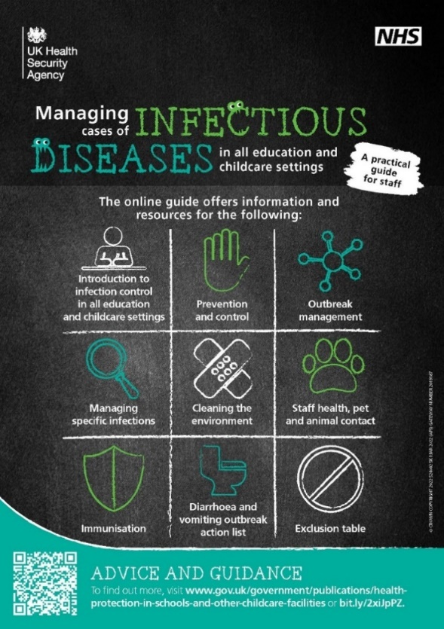 | 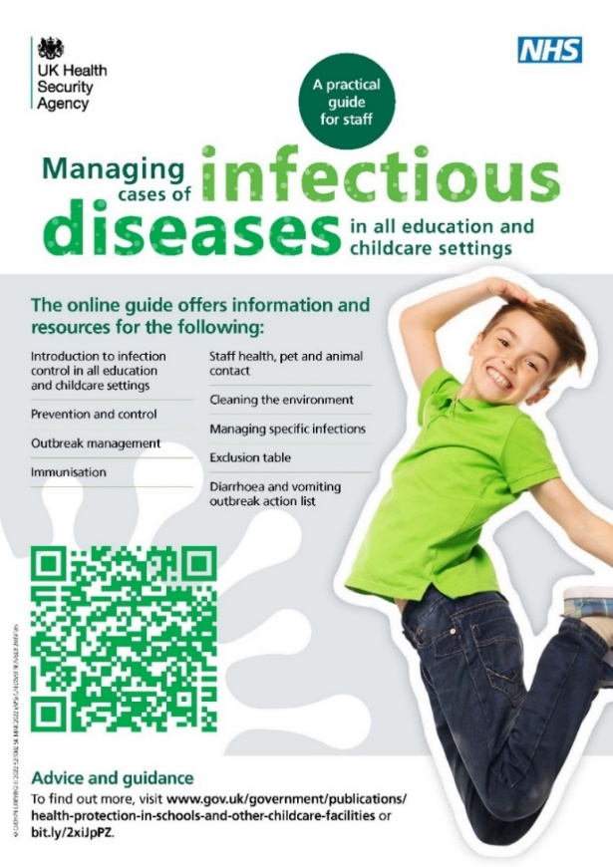 | 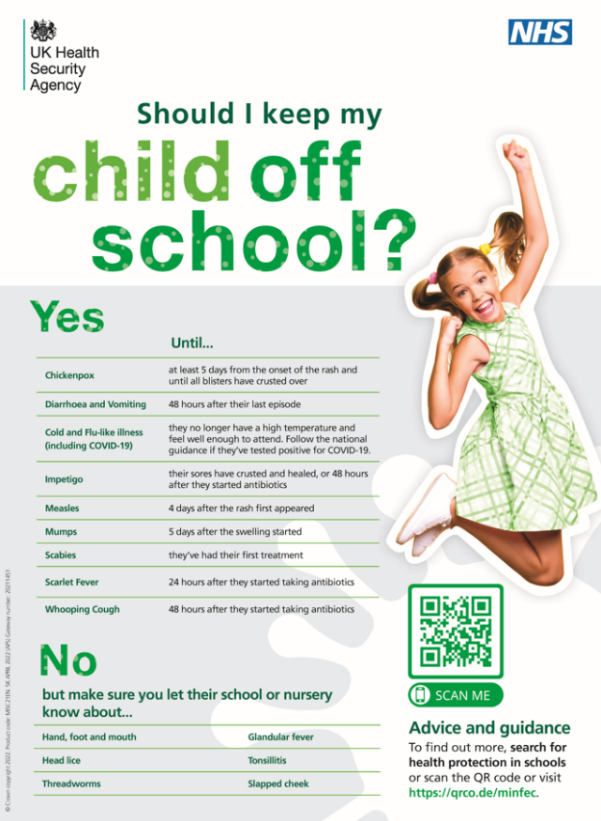
Order a hard/download copy here | Download a copy here | Download a copy here

