Torbay Healthy Learning - Emotional Health & Wellbeing Audit Tool
Before using this audit tool please ensure you have familiarised yourself with Public Health England’s Report – Promoting children and young people’s emotional health and wellbeing – A whole school and college approach. The following diagram presents eight principles to promote emotional health and wellbeing in schools and colleges. Each of these principles will be included within the audit tool to enable for you to assess your progress within each domain and identify priority areas for further developments and action plans.
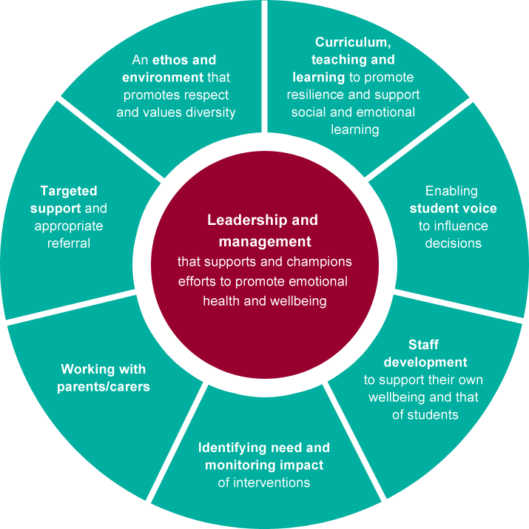
It is recommended that you review this audit on a bi-annual basis and that your associated action plan is reviewed regularly through your own senior leadership team.

Stage 1 - This is a simple assessment of your current position.
You should decide how well your school is meeting each statement, by putting a tick in either the ‘1’, ‘2’ or ‘3’ column using the following scale:
3 = Very good – this is a strength for our school, we are doing well in this area
2 = Ok/Good – We have made some progress or are doing well, but recognise there are some gaps we need to address
1 = Not started – We are aware we need to address this area OR this is not yet a priority for us
Stage 2 – Recording actions
If, in stage 1 you gave yourself a ‘1’ or ‘2’ for some statements, you should identify possible action points that will feed into an action plan to cover or address these areas.
Stage 3 – Recording good practice
If, in stage 1, you gave yourself a ‘3’ you should enter information/evidence for the statements to show how well you are doing at these things.

School Name:

Person who completed:

Date completed:

Review due date:

 |  |  | 1 |  | 2 |  | 3 |  | If you’re a ‘1’ or ‘2’ what could you do to improve?  If you’re a ‘3’ how do you know?
Leadership and Management that supports and champions efforts to promote emotional health and wellbeing
The school provides visible senior leadership for social and emotional health and wellbeing and mental health
(For example: a governor with specific remit, a commitment to emotional health & wellbeing is made in development plans, there is a structured pastoral support system with designated staff responsible for pupil wellbeing, staff know who to go to for advice when they have concerns about pupils emotional wellbeing)

An ethos and environment that promotes respect and values diversity
Emotional Health & Wellbeing is evident within the ethos of our school
(For example: it is referenced in school motto, mission statement, prospectus, on website, open door policy for parents/carers, all members of the school community can communicate this ethos etc.)

The school has an anti-bullying culture, supported by planned curriculum opportunities and effective responses when it happens in the school (For example: policies up to date, regular staff training, regular work with pupils in curriculum and wider learning opportunities such as assemblies, children and staff now what to do when they have a concern about bullying)

There is clear guidance on confidentiality which is communicated to staff and visitors (and pupils where appropriate)

All pupils know what to do if they need to talk to someone in confidence and need advice on their personal wellbeing

Curriculum, teaching and learning to promote resilience and support social and emotional learning
The school builds self-esteem by celebrating the achievements of pupils across all areas of school life.
(e.g. certificates, assemblies, awards, showcase performances, invitations to the Head’s office to showcase work)

The school has a full and broad PSHE curriculum which includes elements of emotional health and wellbeing (e.g. use of set/clearly outlined pshe curriculum programme, integrated into wider curriculum, use of specialist training opportunities and drop down days, special weeks across whole school)

Enabling student voice to influence decisions
Pupils have opportunities, through participation in school life to develop responsibility, build confidence and self-esteem.
(e.g. monitor jobs, ‘interest groups’, peer mediation or playground buddies, cyber mentors, charity work etc.)

The school has mechanisms in place to ensure that the views of pupils are heard and there are examples of things that have changed as a result
(e.g. school council, class consultations)

Staff development to support their own wellbeing and that of students
Staff have access to continuing professional development (CPD) opportunities relevant to emotional health & well being

PSHE training (Staff delivering PSHE curriculum are provided with appropriate CPD opportunities relevant to PSHE and EHWB).

Identifying need and monitoring impact of interventions
The school systematically measures and assesses all pupils social and emotional wellbeing and uses information gathered as the basis for planning activities
(e.g. the school uses validated tools that can measure wellbeing)

Working with parents /carers
The school supports the parents and carers of vulnerable pupils

The school supports members of the school community (pupils, families, staff) at times of crisis such as bereavement etc

Targeted support and appropriate referral
The school has systems to identify and meet the needs of vulnerable children and has arrangements to provide appropriate support
(e.g. young carers, children looked after, disabled, children at risk, special needs, pupils lacking social skills, emotionally vulnerable pupils etc)

The school refers pupils and parents/carers to specialist services that can give professional advice when appropriate

Torbay Healthy Learning - Emotional Health & Wellbeing Whole School Action Plan

Area 1 - Leadership and Management that supports and champions efforts to promote emotional health and wellbeing
Planned Outcome/s | Success indicators | Activities | Timescale | Lead and Job title | Monitoring and Evaluation
What do you want to improve? | How will you know you are on your way to achieving your outcome? | What are you going to do to achieve your outcome? | How long will it take to achieve? | Who will lead the work? | What will you use to measure your success and demonstrate your improvements?

Area 2 - An ethos and environment that promotes respect and values diversity
Planned Outcome/s | Success indicators | Activities | Timescale | Lead and Job title | Monitoring and Evaluation
What do you want to improve? | How will you know you are on your way to achieving your outcome? | What are you going to do to achieve your outcome? | How long will it take to achieve? | Who will lead the work? | What will you use to measure your success and demonstrate your improvements?

Area 3 - Curriculum, teaching and learning to promote resilience and support social and emotional learning
Planned Outcome/s | Success indicators | Activities | Timescale | Lead and Job title | Monitoring and Evaluation
What do you want to improve? | How will you know you are on your way to achieving your outcome? | What are you going to do to achieve your outcome? | How long will it take to achieve? | Who will lead the work? | What will you use to measure your success and demonstrate your improvements?

Area 4 - Enabling student voice to influence decisions
Planned Outcome/s | Success indicators | Activities | Timescale | Lead and Job title | Monitoring and Evaluation
What do you want to improve? | How will you know you are on your way to achieving your outcome? | What are you going to do to achieve your outcome? | How long will it take to achieve? | Who will lead the work? | What will you use to measure your success and demonstrate your improvements?

Area 5 - Staff development to support their own wellbeing and that of students
Planned Outcome/s | Success indicators | Activities | Timescale | Lead and Job title | Monitoring and Evaluation
What do you want to improve? | How will you know you are on your way to achieving your outcome? | What are you going to do to achieve your outcome? | How long will it take to achieve? | Who will lead the work? | What will you use to measure your success and demonstrate your improvements?

Area 6 - Identifying need and monitoring impact of interventions
Planned Outcome/s | Success indicators | Activities | Timescale | Lead and Job title | Monitoring and Evaluation
What do you want to improve? | How will you know you are on your way to achieving your outcome? | What are you going to do to achieve your outcome? | How long will it take to achieve? | Who will lead the work? | What will you use to measure your success and demonstrate your improvements?

Area 7 - Working with parents /carers
Planned Outcome/s | Success indicators | Activities | Timescale | Lead and Job title | Monitoring and Evaluation
What do you want to improve? | How will you know you are on your way to achieving your outcome? | What are you going to do to achieve your outcome? | How long will it take to achieve? | Who will lead the work? | What will you use to measure your success and demonstrate your improvements?

Area 8 - Targeted support and appropriate referral
Planned Outcome/s | Success indicators | Activities | Timescale | Lead and Job title | Monitoring and Evaluation
What do you want to improve? | How will you know you are on your way to achieving your outcome? | What are you going to do to achieve your outcome? | How long will it take to achieve? | Who will lead the work? | What will you use to measure your success and demonstrate your improvements?

